SE 491 BIWEEKLY REPORT 3
sdmay20-25: Consumer Aware Warehouse Management
2/14/20 – 2/27/20
Team Member | Roles
Jimmy Paul  jpaul@craftydelivers.com | Client
Goce Trajcevski  gocet25@iastate.edu | Advisor
Lindsey Sleeth  lssleeth@iastate.edu | Meeting Scribe  Project Manager  Software Developer
Sam Stifter  stifter@iastate.edu | Test Engineer  Software Architect  Software Developer
Omair Ijaz  oijaz@iastate.edu | Quality Assurance Engineer  Meeting Facilitator  Software Developer
Jameel Kelley  jamkelley22@gmail.com | Report Manager  Software Architect  Software Developer
Andrew Smith  arsmith3@iastate.edu | Database Administrator  Quality Assurance Engineer  Software Developer
Elijah Buscho  elijah@iastate.edu | Test Engineer  Software Dev  Proj Manager
Devin Üner  druner@iastate.edu | Software Architect  Machine Learning Specialist

Bi-Weekly Summary

Objective
The objective of this period was to begin work on making data more available within all aspects of our application. Additionally, to begin displaying some of that data. Finally, determining patterns in the data we have to make the best use of the algorithm being generated.

Accomplishments
The frontend team was able to create mockups of what data is going to be shown in Figma. Additionally, some progress was made in implementing those in React. Pattern recognition in the data set was also a focus of the week and a formula was derived for validating accuracy of our recommendations. New queries were created which required “intermediate” objects. This allows more access to manipulate and analyze aspects of the database. Finally, alternative optimization algorithms were analyzed.

Summary of Weekly Advisor Meeting
During our weekly advisor meeting it was brought to our attention that it was important to begin figuring out a timeline for the final report. Additionally, four other points were raised. Firstly documentation of communication and requirements between team individuals is an important aspect of ensuring things don't fall through the cracks. Next, data visualization is an important aspect of the demo for the application and so it is necessary to decide if the calculations for each graph will be stored (cached) on the server in a data warehouse. Additionally, Machine Learning is something that is being continually discussed. Finally, there was discussion of the workload on individuals and ensuring the experience was still a positive one for all team members.

Past Accomplishments (Individual)
Lindsey Sleeth
I worked on mocking up the UI and finalizing the main screen which will show off the data forecasting algorithm.

Here is the first iteration where we listed all products in an order table that need to be ordered on the current day. The plan is that the client will also have a date picker to pick up to x amount of time in the future and see product orders for a specific day.
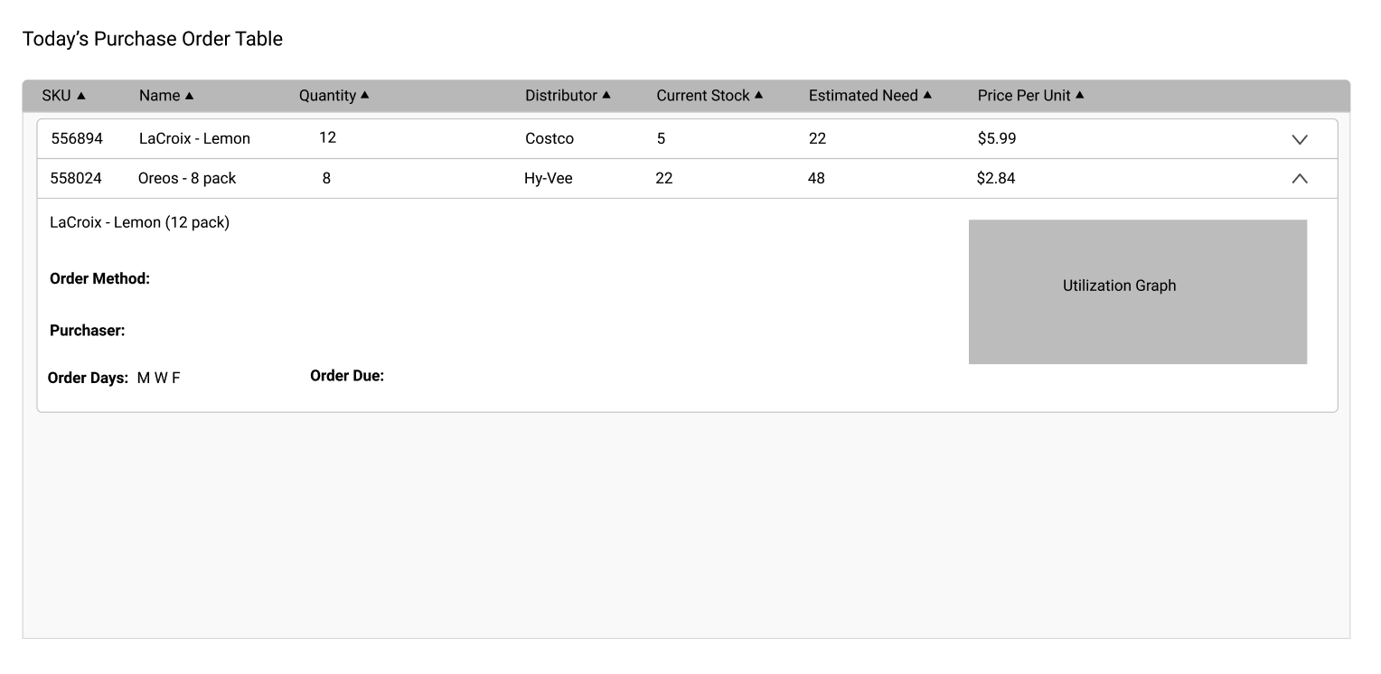
This is the second iteration we grouped the products by distributors since each distributor has an order method, purchaser, and order days and we will add a few more pieces of information in place of those in the first iteration so that we do not duplicate information and the client can have all of the necessary details to order immediately.

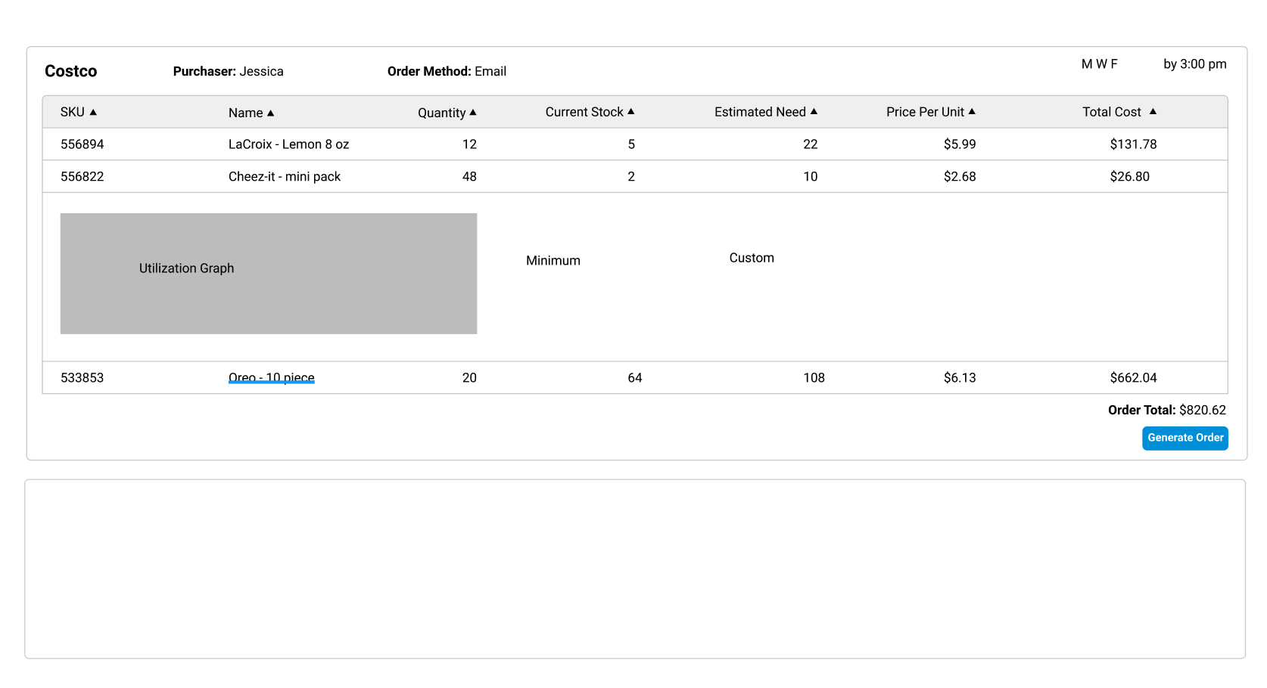

Elijah Buscho
I plotted the 4 data sets we have using python:
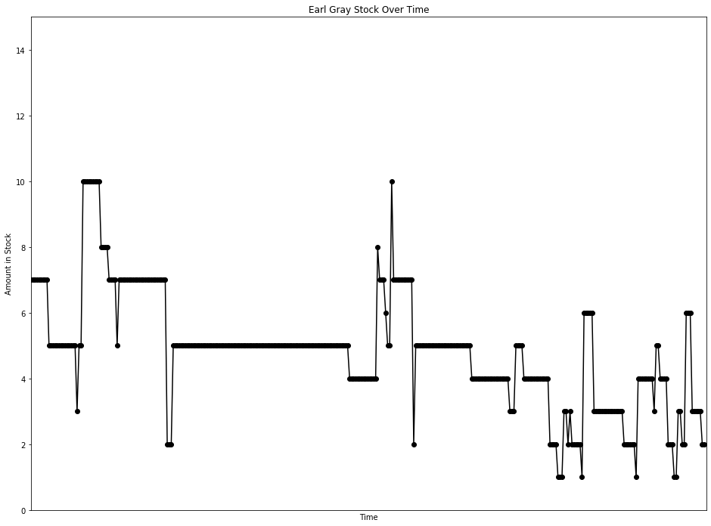
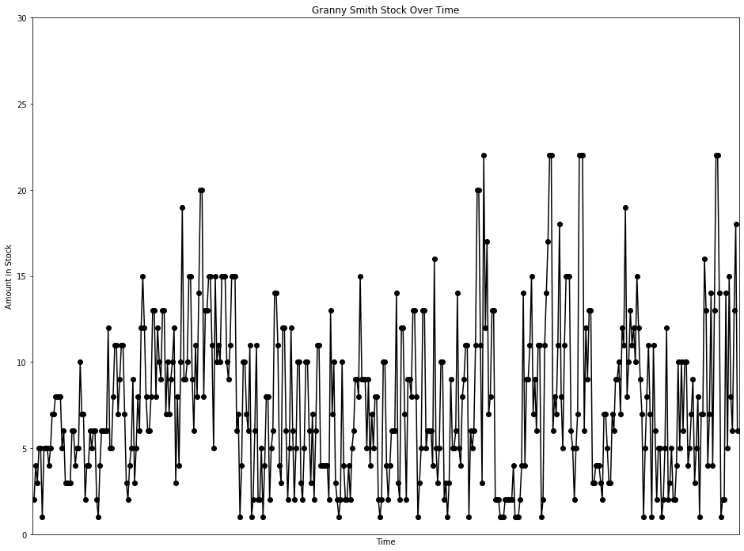
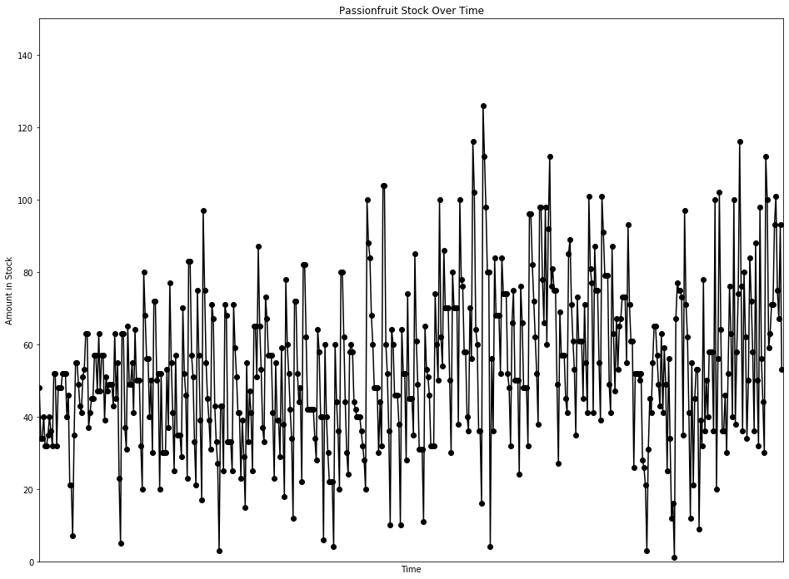
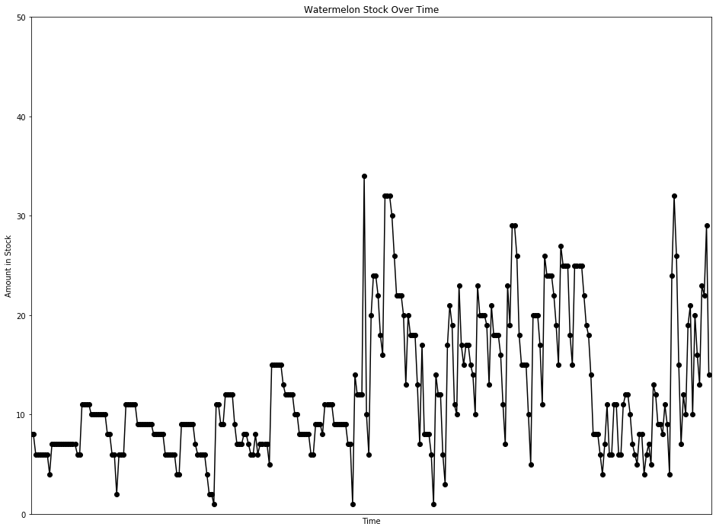
I did some basic data manipulation to see if I could find any patterns. I found that there tends to be a big increase in stock level on one day, and on subsequent days the stock will gradually decrease. Here is the change from day to day on the Passionfruit data with some of the patterns highlighted:

[0, -14, 0, 6, -8, 0, 3, 5, -4, -4, 20, 0, -20, 16, 0, 0, 4, 0, 0, -12, 6, -25, 0, -14, 28, 20, 0, -6, -6, -2, 10, 2, 10, 0, -26, 4, 4, 0, 12, 0, -10, 16, -16, 10, 0, -18, 12, -4, 2, 0, 0, -6, 20, -18, 10, -32, -18, 58, 0, -26, -6, 34, -16, 0, 6, -14, 23, -14, 0, 0, -18, -12, 60, -12, -12, 0, -16, 10, -20, 42, 0, -22, 2, -32, 32, -22, 0, 0, 23, -16, 40, -22, -14, -16, 32, -22, 0, 0, -6, 41, -18, -6, -23, 60, 0, -26, -6, -18, -12, 54, -18, -18, -22, 80, -22, -20, -10, -6, -8, 40, -4, -24, -10, -6, -24, 40, 0, -18, 46, -3, -35, 0, 0, -8, 46, -12, -8, -10, 0, -18, 16, -10, -14, 40, -22, 14, -6, -16, 40, 0, -14, 36, -22, -12, -16, -4, 40, -6, -10, 0, 0, -16, -18, 32, -16, 0, -10, 30, -21, -20, 60, -18, -8, -10, -8, -22, 60, 0, -20, -8, 4, -26, 60, 0, -20, -20, 0, 0, 0, 0, -8, -6, 36, -6, -18, 0, -34, 54, -20, -10, -8, 0, 0, -18, 56, -16, -8, -16, 60, 0, -18, -18, -14, -6, 34, 2, -2, -14, -2, -2, 0, 0, -4, -4, -4, -8, 80, -12, -4, -16, -8, -12, 0, 0, -18, 14, -12, 72, 0, -44, -8, -16, -26, 54, -4, -14, 0, 0, -8, -28, 54, -12, 0, -24, 46, -29, 0, 0, -10, 50, -24, -12, -18, 0, 0, -20, 54, -12, -2, -5, -14, 0, 0, 42, -14, -10, 50, -38, -8, 32, -16, 0, 0, -20, -20, 50, -10, 0, 0, -32, 62, -22, -2, -18, 0, -18, -4, 34, -14, 60, -14, -38, -4, -24, 0, -20, 110, -14, -14, -18, 0, -76, 52, -20, 48, -16, 0, 0, -16, 32, -10, 0, 0, -22, -4, -16, 34, 9, -25, 0, 0, -26, 52, -10, -18, 0, 0, -16, 64, 0, -14, -10, -10, -10, -14, 60, 0, -20, -12, 32, -38, 32, 20, -36, 5, -6, 0, -26, -22, 42, -12, 0, 0, -12, -4, 44, 4, -18, -10, -8, -18, 38, -12, 0, 0, -16, 26, -16, -14, 60, -20, -4, -36, 46, -12, 0, -20, -16, 62, -10, -12, 0, 0, -30, -8, 46, -24, -16, 20, -14, 12, 2, 6, 0, 0, -18, 38, -22, -10, 0, -35, 26, 0, 0, -2, 2, -24, -2, -5, -18, 28, 14, -4, 14, 10, 0, -8, -8, -6, 20, -22, 18, -10, -24, 31, -22, -22, 4, -15, 66, 10, -2, 0, -2, -38, 62, -26, -9, -21, -29, 43, -34, 24, 8, 0, -44, 30, -7, 46, -42, 14, -10, 18, 0, 0, -22, 64, -80, 36, 46, -38, -28, 0, 10, -16, 22, 24, -13, -23, 60, -62, 20, 16, 42, -40, -40, 44, -18, -28, 16, 34, -12, -14, -22, 52, -38, -18, 66, -42, -12, -14, 82, -12, -41, 4, 8, 0, 22, 8, -26, -8, 26, -40]

This matches our understanding of how ordering works. It seems as though big orders happen every few days to account for sales on subsequent days. Because stock level is only taken once per day, we can’t account for multiple orders/sales on the same day, so in order to understand the pattern fully we need data on orders or sales.

I also determined the formula for validating accuracy of our recommendations. Our goal is to have less missed sales than the current process. In order to evaluate this we need to subtract demand (sales + missed sales) from our recommendation. This will get us missed sales of recommendation. In order to calculate improvement we divide missed sales recommendation by missed sales real.

Jameel Kelley
The creation of the Product Order Table has begun this week. The frontend team had fleshed out a first version of the wireframe of said table and this week it was implemented with React on the frontend. Fake data was used but it will later be connected to the endpoints to receive real data.

Andrew Smith
Worked with Sam to get inner join queries to work with Spring. We finally did get it working with DTOs, data transfer objects, with a modified query. I’m also continuing to work on getting more data from the database with complex queries.
Here is a query for Missed items, missed sales, for a sku and gives a timeline for missed counts: Select
distributors.id as dist_id,
distributors.name as client_name,
finalized_purchases.created_at as order_date,
missed_items.count as order_count,
skus.id as sku_id,
products.name as product_name,
TRIM(LEADING ' - ' FROM CONCAT(coalesce(product_sizes.number_of_packs || ' ' || product_sizes.pack_name || ' of '),product_sizes.units, ' - ', product_sizes.size_of_measurement, ' ', product_sizes.unit_of_measurement, ' ', product_sizes.name)) AS size_name
From finalized_purchases
inner join corporate_users
on corporate_users.id = finalized_purchases.corporate_user_id
inner join distributors
on distributors.corporate_user_id = corporate_users.id
inner join missed_items
on missed_items.finalized_purchase_id = finalized_purchases.id
inner join purchasing_sizes
on purchasing_sizes.id = missed_items.purchasing_size_id
inner join skus
on skus.id = purchasing_sizes.sku_id
inner join products
on products.id = skus.product_id
inner join product_sizes
on product_sizes.id = skus.product_size_id
where
corporate_users.internal_on_hand = false and
corporate_users.ignore_price_and_cost = false and
finalized_purchases.deleted is false and
finalized_purchases.order_status = 0 and
skus.id = 2833
order by
finalized_purchases.created_at,
distributors.id;

Omair Ijaz
Since last week, I began working with Andrew and Sam to help with creating queries. Individually, I have been looking into the database and have been assigned queries to work on.

Sam Stifter
I worked to help create Postgres Queries within Spring. It was necessary to create a few “intermediate” objects to represent the results that come out of our queries since they don’t correspond to an existing object in Spring.

Devin Üner
Looked more into some optimization algorithms, modified the backend a bit to connect with front end perfectly.

Individual Contributions
Name | Individual Contributions | Hours this Period | Hours Cumulative
Lindsey Sleeth | Mockups of Product Order Table, Visualizing Data | 10 | 13
Jameel Kelley | Product Order Table | 10 | 19
Sam Stifter | More Data Queries and Server work | 10 | 32
Andrew Smith | Database work and query development | 16 | 38
Omair Ijaz | Tables wiki page and Database Querying | 11 | 30
Elijah Buscho | Data visualization, manipulation, validation | 10 | 35
Devin Üner | Genetic algorithms, data manipulation, visualization, back end, front end | 4 | 10

Pending Issues
Lindsey Sleeth
No major issues. Now that the mockup has been completed, it will be a matter of working with Jameel to complete the UI and working with the backend team to make sure the data is in a digestible format for us to work with it on the frontend.

Elijah Buscho
Distributor order history data is required to turn machine learning predictions on stock level into order recommendations. Client demand data (missed sales and order history) per product is needed to evaluate the accuracy of these recommendations.

Jameel Kelley
Integration has to wait until endpoints are out of code review and merged into master. No major issues

Andrew Smith
Still cannot figure out how to get client order history counts. I can get dates and cost amount for a client's order but I cannot get the amount that they ordered of each product.

Omair Ijaz
There are still some queries giving us issues; we have been in close contact with our client Jimmy asking for advice when needed.

Sam Stifter
New data from the client needs to be imported to the server table.

Devin Üner
None

Upcoming Plans
Lindsey Sleeth
I plan to work with Jameel and add any minor details as necessary to the mockup of the UI and to work on building out the tables and views to visualize the data. We maybe need to add 1 - 2 more mockups of different pages we would like our user to be able to interact with in order to visualize the data. If so, we will work with the rest of the team and the client to finalize these and get them assigned to tasks and develop them in the frontend.

Elijah Buscho
Experiment with machine learning techniques on the available data paying particular attention to buffering stock levels and using special loss functions to evaluate prediction accuracy in order to over predict to eliminate missed sales in cases where expiration isn’t an issue.

Jameel Kelley
Plan out UI in detailed wireframe. Square away the wireframe models with the team to ensure that demo will work and include all aspects necessary to demonstrate features backend worked on.

Andrew Smith
I plan on setting more endpoints up for the queries I have already. Document them in the apiary. Also continue working on the client order history getting the amount ordered.

Omair Ijaz
I have been assigned to create a query and create an endpoint for it. I will further research the database and write documentation in our git wiki.

Sam Stifter
I will continue to work on getting the new data imported as well as working on the backlog of queries needed by the algorithm team and frontend team.

Devin Üner
More neural network optimization stuff.

